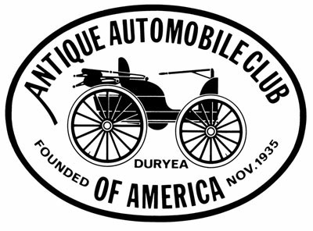
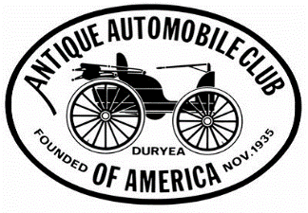

Schedule for 2017

- May 13th The Spring Fling @ Florence Flea Market

- Sept 9th Annual Antique Classic Car Show @ Florence Flea Market

- Oct 14th SC Sweet Potato Festival, Darlington

- Nov 4th SC Pecan Festival, Florence

24 Distinct Classes
DASH PLAQUES TO FIRST 100
TROPHIES AWARDED TO TOP 3 IN EACH CLASS
BEST NON-PRODUCTION
BEST PRODUCTION
Register 8am - noon
Registration fee $20.
MAYOR’S CHOICE

ALL ENTRIES WILL BE JUDGED BY SWAMP FOX AACA CLUB MEMBERS
THE JUDGING WILL USE A POINT SYSTEM
NO SWAMP FOX OLD CARS WILL BE JUDGED
MUSIC PROVIDED BY THE SWAMP FOX OLD CAR CLUB

**please note Annual Antique Classic Car Show will possibly have a different trophy structure**

For more information visit our website: http://swampfox.aaca.com/
Or call: Al Robinson, President 843-496-7207
Sammy Lee, VP 843-992-6082

